Project Charter/Plan
for “small” Projects

This document outline is based on the IEEE Standard 1058.1-1987 for Project Management Plans.
This is the controlling document for managing a Production Services project, and it defines the technical and managerial processes necessary to deliver the project requirements.
The paragraphs written in the “Comment” style are for the benefit of the person writing the document and should be removed before the document is finalized.

Project Name: | Enter Project Name Here | Project Number: | RFP 000000-0

Version: [##]

[DD MMM YYYY]

[Authors]

Revision Chart
This chart contains a history of this document’s revisions. The entries below are provided solely for purposes of illustration. Entries should be deleted until the revision they refer to has actually been created.
The document itself should be stored in revision control, and a brief description of each version should be entered in the revision control system. That brief description can be repeated in this section. Revisions do not need to be described elsewhere in the document except inasmuch as they explain the development plan itself.
Version | Primary Author(s) | Description of Version | Date Completed
Draft | TBD | Initial draft created for distribution and review comments | TBD
Preliminary | TBD | Second draft incorporating initial review comments, distributed for final review | TBD
Final | TBD | First complete draft, which is placed under change control | TBD
Revision 1 | TBD | Revised draft, revised according to the change control process and maintained under change control | TBD
Revision 2 | TBD | Revised draft, revised according to the change control process and maintained under change control | TBD
etc. | TBD | TBD | TBD

Contents
New paragraphs formatted as Heading 1, Heading 2, and Heading 3 will be added to the table automatically. To update this table of contents in Microsoft Word, put the cursor anywhere in the table and press F9. If you want the table to be easy to maintain, do not change it manually.
1. Introduction 4
1.1 Project Background and Rationale 4
1.2 Responsibility 4
1.3 Scope 4
1.4 Project Objectives 4
1.5 Project Deliverables 5
1.6 Milestones 5
1.7 Business Case 5
2. Project Organization 6
2.1 Organizational Structure 6
2.2 Project Responsibilities 7
3. Managerial Process 8
3.1 Assumptions, Dependencies, and Constraints 8
3.2 Risk Management 8
3.3 Monitoring and Controlling Mechanisms 8
3.4 Quality Plan 8
3.5 Change Control Plan 9
3.6 Staffing Plan 9
4. Technical Process 10
4.1 System Documentation 10
4.2 Project Support Functions 10
5. Work Breakdown structure, Schedule, and Budget 11
5.1 Work Breakdown Structure 11
5.2 Budget 12
5.3 Schedule 12
6. Additional Components 13
7. Appendices 14

1. Introduction
This section should describe the project and the product(s) delivered. No text is necessary between the heading above and the heading below unless otherwise desired.

Project Background and Rationale
How did we get here? Why do we want to do this project? Why do we want to do it now?

Responsibility

Executive Sponsor: | Enter name and title here | Reviewers: | Enter name here
Project Sponsor: | Enter name and title here |  | Enter name here
Project Manager: | Enter name and title here |  | Enter name here
Acceptors: | Enter name and title here |  | Enter name here
 | Enter name and title here |  | Enter name here
 | Enter name and title here |  | Enter name here
 | Enter name and title here |  | Enter name here
 | Enter name and title here |  | Enter name here
 | Enter name and title here |  | Enter name here

Scope
Identify project boundaries, what’s included, and what is not covered by this project..

1.4 Project Objectives
What specific problem is this project trying to solve and what would constitute an acceptable solution?
How will the infrastructure be different once the project is successfully completed?

1.5 Project Deliverables
List all of the major items to be delivered, delivery dates, delivery locations, delivery method and quantities necessary to satisfy the project’s requirements.

1.6 Milestones
List those significant points that will occur during the execution of the project that can be used to assess its progress.

Business Case
State whether a business case has been prepared or not and if one has been developed provide a reference to the document. Indicate whether the business case was approved.
Is this project to be gated or not? If so, what is the composition of the gating committee.

Project Organization

Organizational Structure
Describe the internal management structure of the project. Use an organization chart to describe the lines of authority and communication within the project. A sample follows.
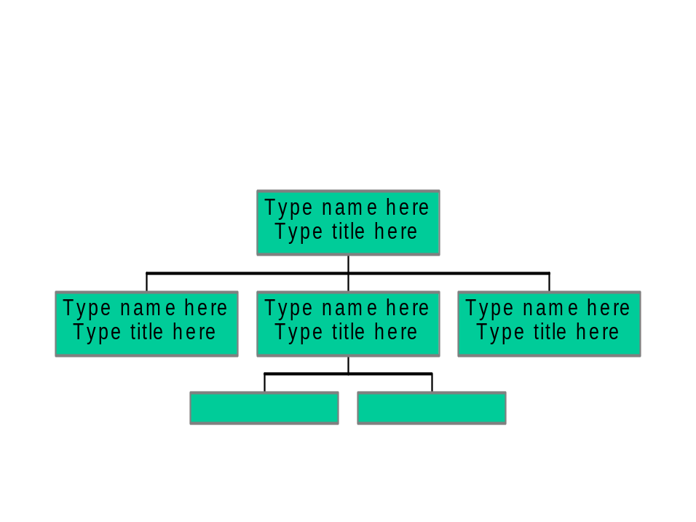

2.2 Project Responsibilities
Use a RASCI chart to identify who is responsible for what within the scope of this project.
For each activity required by the project, identify who is responsible for doing the work (R); who is accountable for getting the work done (A); who must be consulted prior to completing the work (C); who must provide support in the creation and delivery of the work products (S); and who needs to be informed after the fact (I).
These people are the project’s stakeholders. An example follows.

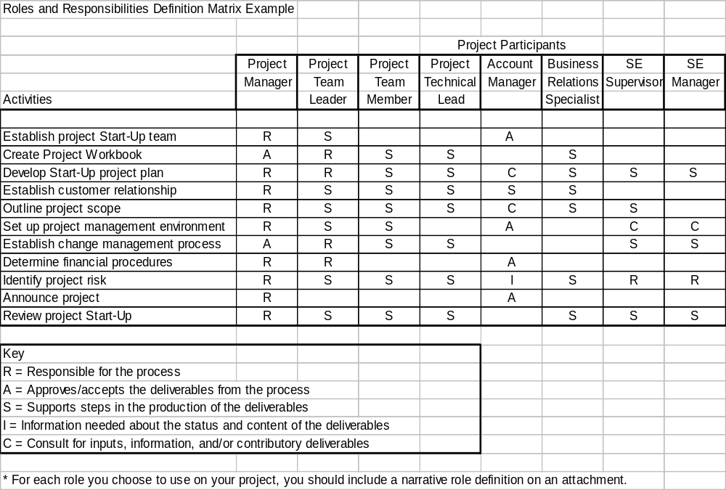

Managerial Process

Assumptions, Dependencies, and Constraints
Describe the assumptions upon which the project plans are based, the dependencies of the project plans, and the constraints upon the project plans (e.g., schedule, budget, quality, functionality, etc.) An assumption is something that can effect the project but you cannot control.

3.2 Risk Management
Describe any serious risks that might affect the project and how you plan to deal with them.

Monitoring and Controlling Mechanisms
Describe how project cost, schedule, quality, and functionality will be tracked throughout the project. How often will the reviews take place, with whom? A sample progress report is provided.

Quality Plan
A sample plan is provided.

Change Control Plan
A simple change control process must be established. A sample is available.
A simple change log should be kept; a template is provided.

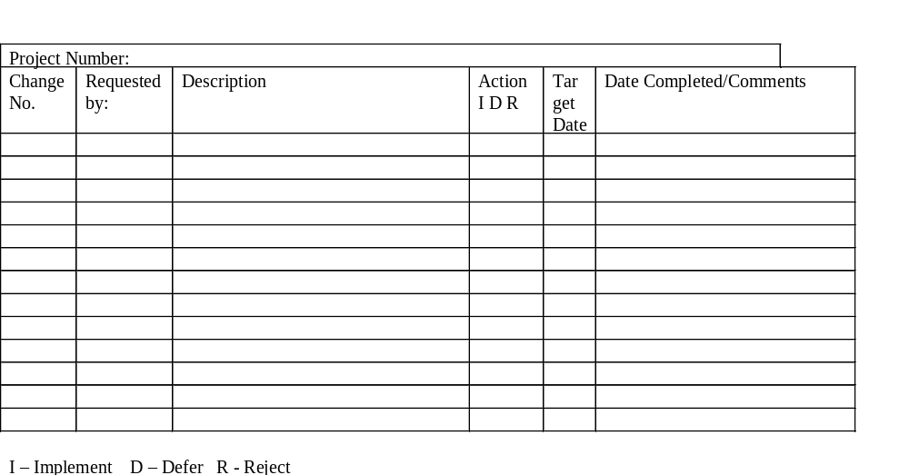

3.6 Staffing Plan
Describe the numbers and types of personnel needed to conduct the project. Describe the required skill levels, start times and duration on the project

4. Technical Process

4.1 System Documentation
List the documents that will be developed for the project, including milestones, reviews, and signoffs for each document.
Two kinds of documentation are necessary; those that are outputs of the delivery process, and those that are fundamental to the project management process. Some of these documents may not be relevant for every project
The documentation list from the delivery process might include (this is not an exhaustive list):
- Sys tem Requirements Specification
- System Design
- Test Plan
- Installation Plan
- Transition/Cut over Plan
- Service Level Agreement
- Operations Manual
- User Manual
The project management process has only two principal documents:
- Project Charter/Plan (this has many embedded documents)
- Project Status and Tracking Report

4.2 Project Support Functions
If the project requires supporting processes such as configuration management, problem management, Help Desk support, etc, identify who is responsible for providing the function.

5. Work Breakdown structure, Schedule, and Budget

5.1 Work Breakdown Structure
The work breakdown structure (WBS) is a method of representing, in a hierarchical manner, the component parts of a process or product. A product WBS partitions a large entity into its components. Each component and its interfaces are identified, resulting in a clearer identification of the larger system.
The project should be de-composed into at least three levels of detail with the lowest level being the tasks to be assigned to individual contributors. A short article describing the process is available. A sample template follows.
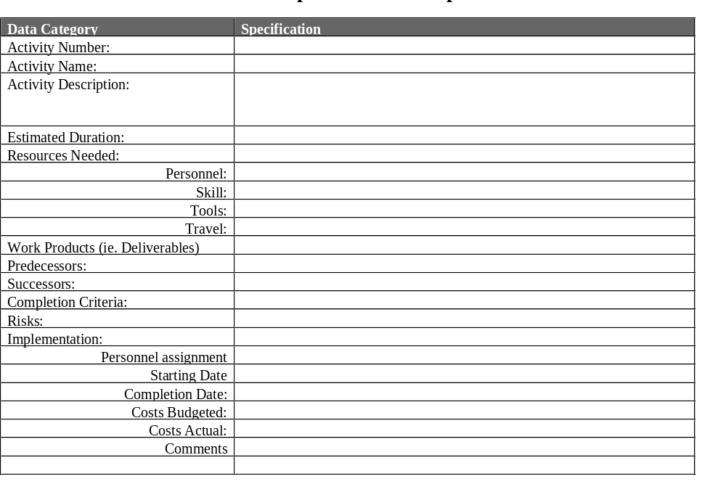

5.2 Budget
Describe the project’s budget allocated to capital, staffing costs, and consulting
As of mm-dd-yy
 | Capital Costs |  |  |  |  | Manpower
 |  | Actual |  |  |  |  | Actual
 | Budget | To Date | Committed | Expected | Remainder | Budget | To Date | Expected | Remainder
Task 1 |  |  |  |  | 0 |  |  |  | 0
Task 2 |  |  |  |  | 0 |  |  |  | 0
Task 3 |  |  |  |  | 0 |  |  |  | 0
. |  |  |  |  | 0 |  |  |  | 0
. |  |  |  |  | 0 |  |  |  | 0
. |  |  |  |  | 0 |  |  |  | 0
. |  |  |  |  | 0 |  |  |  | 0
. |  |  |  |  | 0 |  |  |  | 0
. |  |  |  |  | 0 |  |  |  | 0
Task n |  |  |  |  | 0 |  |  |  | 0
 |  |  |  |  | 0 |  |  |  | 0
 |  |  |  |  | 0
 | 0 | 0 | 0 | 0 | 0 |  | 0 | 0 | 0

5.3 Schedule
Describe the schedule for the various project functions, activities, and tasks, taking into account the various dependencies and required milestone dates and deliverable dates. You can express schedules either as absolute calendar dates or as times relative to key project milestones (e.g., “requirements signed off + 60 days”).

6. Additional Components
Include additional components needed to manage your specific project. Possibilities include subcontractor management plans, security plans, training plans, hardware/software procurement plans, facilities plans, installation plans, and maintenance plans.

7. Appendices
Include supporting detail that would be too distracting to include in the main body of the document.

